Droxford Parish Council
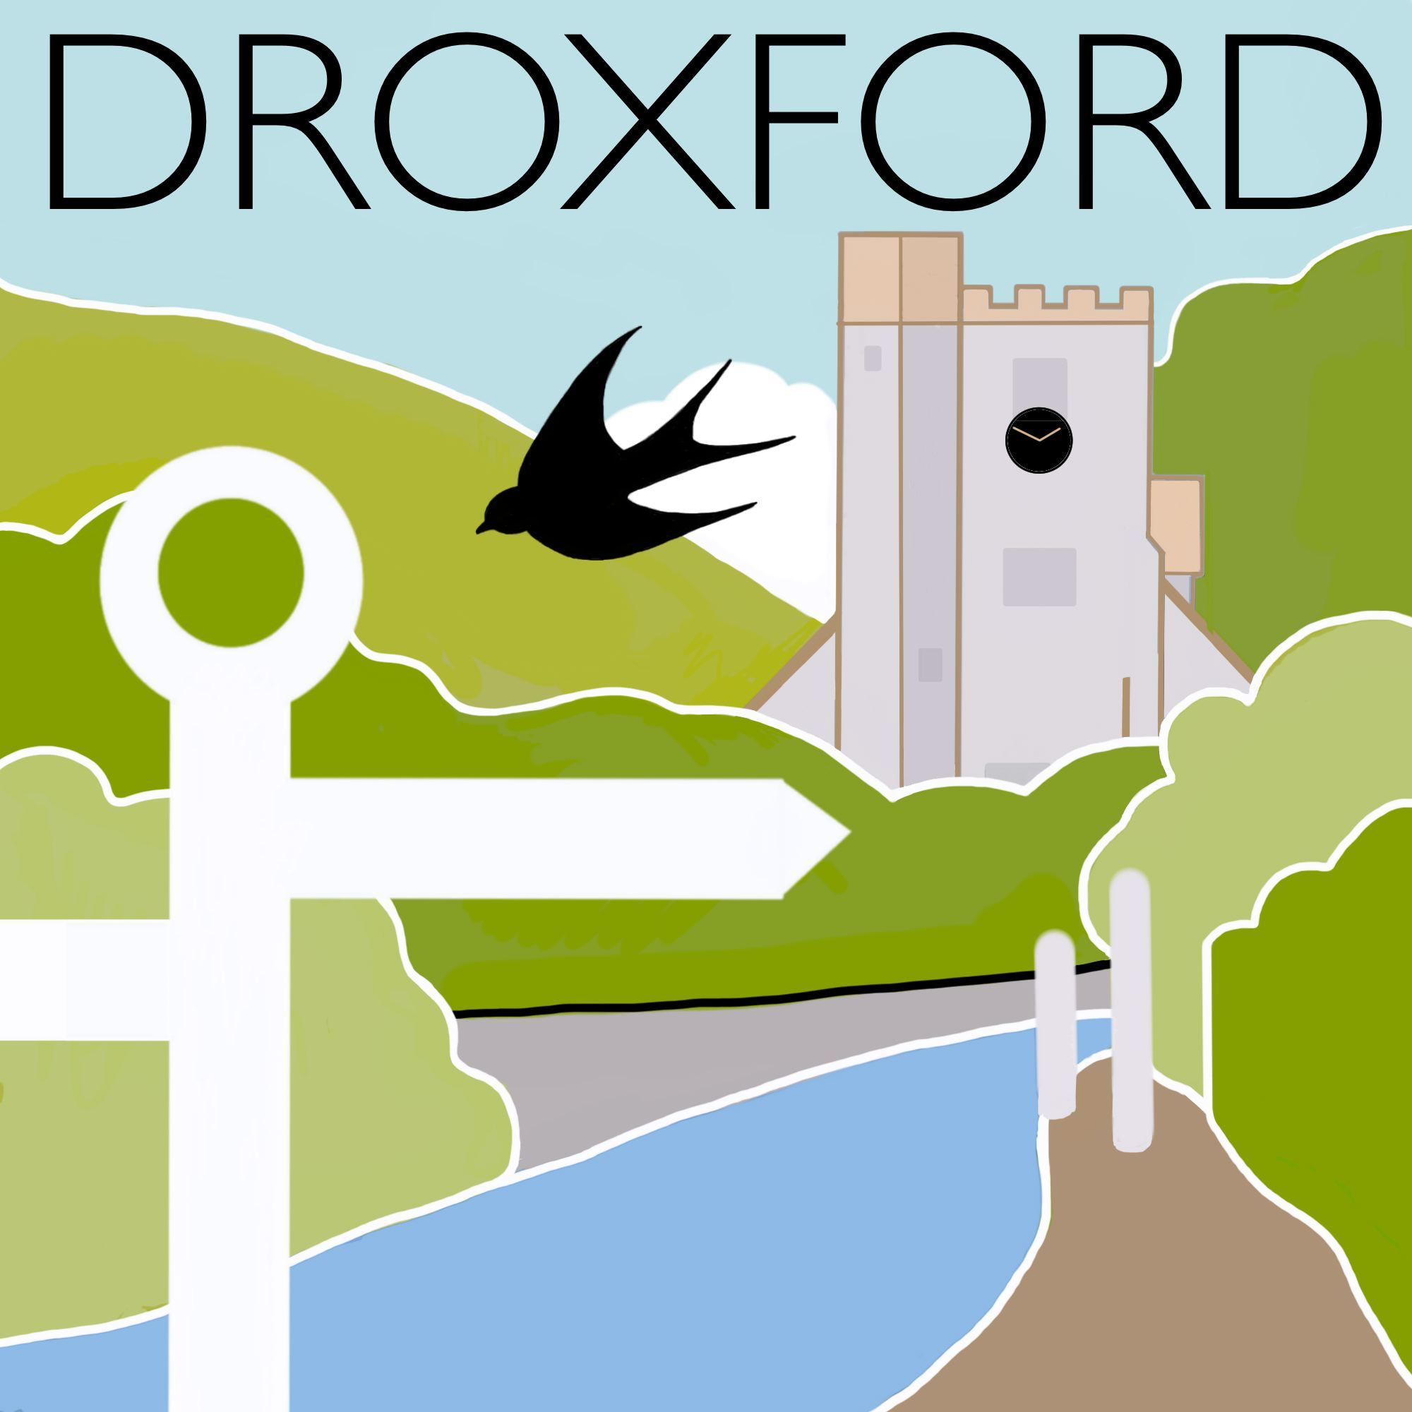
www.droxfordweb.co.uk
October 2016

Dear Droxford Resident,

Concerns are frequently expressed in and around the village relating to parking, highways, traffic and road safety. The Parish Council is committed to a long-term strategy to make improvements where possible. An important first step in this process is to identify shortfalls in available parking spaces and what – if anything – can be done to improve the situation.

Whilst it is acknowledged that a number of areas within the Parish have sufficient off-road parking within properties, in order to provide evidence of need to Hampshire County Council, this survey is being distributed to ALL residents. If no response is received, the assumption will be made that current provision is considered to be entirely satisfactory within a given area.

Please answer the 4 questions below before returning your completed survey to the collection box at the Post Office. If you prefer to complete it electronically, you may download it from the website – www.droxfordweb.co.uk - and email it to the Parish Clerk at clerk.droxfordpc@gmail.com . Please accept the assurance of the Parish Council that all information provided will be used solely for the purpose of defining the requirement for public parking spaces. Return of completed surveys by 31st October would be appreciated.

NAME OF YOUR STREET/LANE/ROAD:

…………………………………………………………………………………………………………………

- How many vehicles are registered at your address?
- How many vehicles (including work vans) are ordinarily parked/garaged within your own property?
- How many regularly require parking beyond your boundary on a public road, delineated parking space or ‘off-road’?
- If you park outside your property boundary, please state where and the preference order for seeking a space (eg within The Park , Fire Station, The Square)?

If you are unable to return this to the Post Office and would like it to be collected, please telephone the number below. Thank you for your cooperation in assisting the Parish Council to improve our village.

