The Rude Mechanical Theatre Company are coming!
Don’t miss them!
The Rudes are touring again this summer with a great new show and will be at…

The Old Rectory, Droxford
Saturday 16th July at 7.30

You won’t want to miss their brand of high tempo, physical theatre performed by some of the best actor / musicians around and designed to make you laugh out loud… and make you think.

The new show is

Gods and Dogs
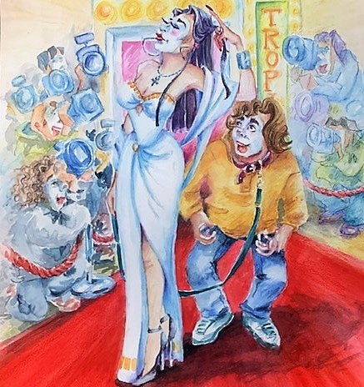
This new comic dystopian allegory is set in 2084 on the fictitious island of Abatina in a world where people are either glamorous celebrities or slobbering dog-like followers of them gripped to their telepafones – with the exception of the Nevnops (Not Very Nice People) as the President, Big Al, calls them.
The story follows Tina who enters ‘Marriage Maker’, a ‘telepavision’ gameshow. The idea of the game is if you win you get to marry the super-glamorous footballer, Harry Best, on the Saturday, have a weekend of love, then divorce him on the Monday. ‘All the fun & no ties!’ as the compere, Rich Nobb, puts it.
Unfortunately, Tina makes the mistake of falling in love when she wins & doesn’t want to divorce. Doreen, her best friend, has her own opinion, but then she might be a Nevnop & the Mind Police might get to her first & send her to the wolves on the ‘Other Side’ - a dangerous world over ‘the mountain’ where the inhabitants of Abatina, according to Big Al, must not go, with dangerous free-thinkers & wolves that might get them.
Will Tina get her man? Will Doreen escape the Mind Police? You’ll have to come to find out! Get your tickets now.

BOOK ONLINE AT therudemechanicaltheatre.co.uk or email therudes1948@gmail.com, or ring 01323-501260
TICKETS – Adults £22, Seniors £21, Students £15, Children £10, Group of 4 booking & coming together £76, Family group (any two adults & two children) £54. Group of 10 or more £18 each (Only bookable by ringing 01323-501260).
Bring your own chairs. Note that chairs so high that they obscure the view of people sitting behind will not be admitted. Bring picnics & warm clothes for a typical English summer evening!

FOR MORE INFORMATION GO TO our website
www.therudemechanicaltheatre.co.uk
or ring 01323-501260 or email therudes1948@gmail.com

